**SE 102.3 – Web Based Application Development**

**Tutorial**

Name: E W V Pesara

ID : 26708

1. Write down the HTML codes required to generate the following outputs.

<!DOCTYPE html>

<html>

<body>

<ul style=”disc”>

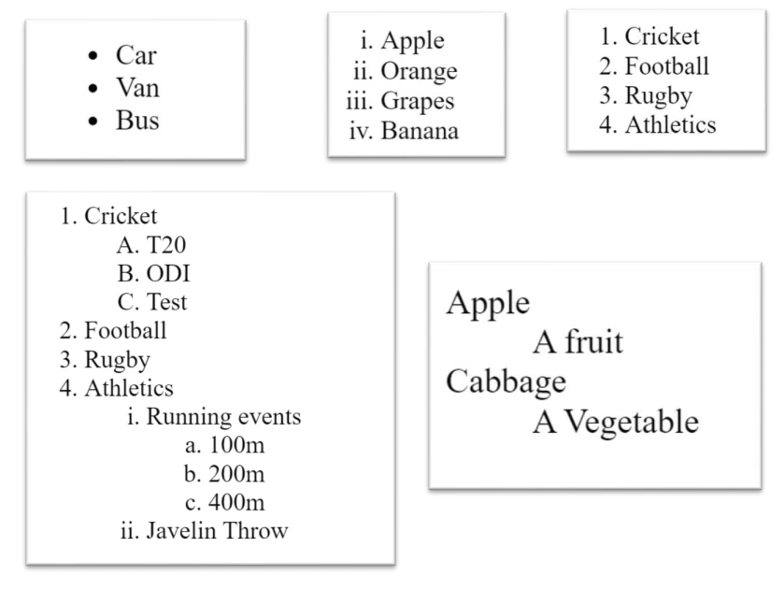



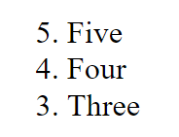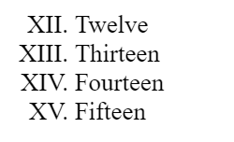

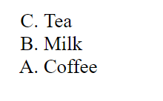

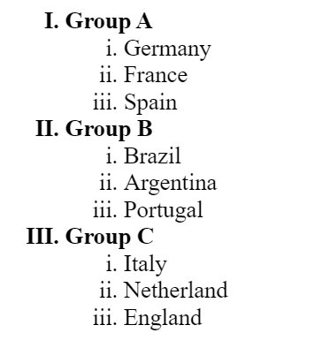

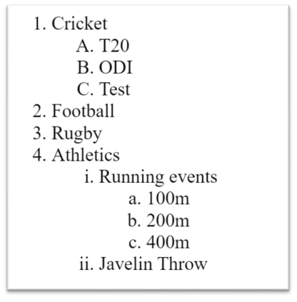

1. <!DOCTYPE html>

<html>

<body>

<ul type=”disc”>

<li>car</li>

<li>Van</li>

<li>Bus<</li>

</ul>

</body>

</html>

1. <!DOCTYPE html>

<html>

<body>

<ol type=”i”>

<li>Apple</li>

<li>Orange</li>

<li>Grapes</li>

<li>Banana</li>

</ol>

</body>

</html>

1. <!DOCTYPE html>

<html>

<body>

<ol>

<li>Cricket</li>

<li>Football</li>

<li>Rugby</li>

<li>Athletics</li>

</ol>

</body>

</html>

1. <!DOCTYPE html>

<html>

<body>

<dl>

<dt>Apple</dt>

<dd>A fruit</dd>

<dt>Cabbage</dt>

<dd>A vegetable</dd>

</dl>

</body>

</html>

1. <!DOCTYPE html>

<html>

<body>

<ol type="I" start="12">

<li>Twelve</li>

<li>Thirteen</li>

<li>Fourteen</li>

<li>fifteen</li>

</ol>

</body>

</html>

1. <!DOCTYPE html>

<html>

<body>

<ul>C. Tea</ul>

<ul>B. Milk</ul>

<ul>A. Coffee</ul>

</body>

</html>

1. <!DOCTYPE html>

<html>

<body>

<ul>5. Five</ul>

<ul>4. Four</ul>

<ul>3. THREE</ul>

</body>

</html>

1. <!DOCTYPE html>

<html>

<body>

<ol type=”I”>

<li><b>Group A</b></li>

<ol type=”i”>

<li>Germany</li>

<li>France</li>

<li>Spain</li>

</ol>

<li><b>Group B</b></li>

<ol type=”i”>

<li>Brazil</li>

<li>Argentina</li>

<li>portugal</li>

</ol>

<li><b>Group C</b></li>

<ol type=”i”>

<li>Italy</li>

<li>Netherland</li>

<li>England</li>

</ol>

</ol>

</body>

</html>

1. <!DOCTYPE html>

<html>

<body>

<ol >

<li>Cricket</li>

<ol type=”a”>

<li>T20</li>

<li>ODI</li>

<li>Test</li>

</ol>

<li>Football</li>

<li>Rugby </li>

<li>Athletics </li>

<ol type=”i”>

<li>Running Events</li>

<ol type=”a”>

<li>100m</li>

<li>200m</li>

<li>400m</li>

</ol>

</ol>

</ol>

</body.

</html>

</ol>

</body>

</html>